
Faculty of Artificial intelligence Engineering

Department of AI & Data Science

Early Detection of Diabetic Retinopathy
Using Deep Learning

Prepared by
Mohammad Barazi
Mohammad Khir Al homsi

Supervised by
Dr. Nisreen Sulayman
Eng. Zeinab Baghdadi

2025-2026

Faculty of Artificial intelligence Engineering
Department of AI & Data Science

SUPERVISOR CERTIFICATION
I certify that the preparation of this project Early Detection of Diabetic Retinopathy Using Deep Learning
prepared by Mohammad Barazi & Mohammad Khir Alhomsi
Was made under my supervision at the Faculty of Engineering in partial fulfillment of the Requirements for the Degree of Bachelor

Name:

Date:

Signature:

Abstract
This project presents an AI-based system for automated grading of diabetic retinopathy severity from retinal fundus images using deep learning. The goal is to develop a robust and scalable model capable of classifying diabetic retinopathy into five ordinal grades (0–4) on the APTOS 2019 dataset. The dataset contains 3,662 clinician-labeled images and exhibits a clear class imbalance across the five grades, which can bias standard classifiers toward the majority class. To address these challenges, a transfer-learning approach was adopted using an EfficientNetB3 backbone pretrained on ImageNet, with a regression-based output head to better reflect the ordinal nature of the labels. Key preprocessing steps included removing dark borders/background artifacts via image cropping, resizing to a fixed resolution, and normalization to reduce variability arising from different acquisition conditions. Training was conducted using stratified 5-fold cross-validation with class-weighted optimization to mitigate imbalance effects. In addition, an optimized thresholding strategy was applied to map continuous predictions to discrete grades, explicitly maximizing the Quadratic Weighted Kappa (QWK), the standard metric for APTOS 2019. The model achieved strong validation performance with a mean best-fold QWK of 0.860 (std 0.014) and a peak fold QWK of 0.887. The results indicate that combining ordinal-aware modeling with threshold optimization can improve agreement with clinical grading, supporting practical use cases such as large-scale screening and decision support, while highlighting opportunities for future work in external validation, interpretability, and more advanced imbalance handling.

الملخص
يقدّم هذا المشروع نظاماً قائماً على الذكاء الاصطناعي للتصنيف الآلي لشدّة اعتلال الشبكية السكري اعتماداً على صور قاع العين باستخدام تقنيات التعلّم العميق. يهدف العمل إلى تطوير نموذج قوي وقابل للتوسّع قادر على تصنيف اعتلال الشبكية السكري إلى خمس درجات مرتّبة (0–4) بالاعتماد على مجموعة بيانات APTOS 2019. تحتوي مجموعة البيانات على 3,662 صورة مُعنونة من قبل مختصين، وتُظهر اختلالاً واضحاً في توازن الفئات عبر الدرجات الخمس، ما قد يسبّب انحياز النماذج التقليدية نحو الفئة الأكبر. لمواجهة هذه التحديات، تم اعتماد منهجية نقل التعلّم باستخدام بنية EfficientNetB3 المُدرّبة مسبقاً على ImageNet، مع رأس إخراج بصيغة انحدار (Regression) لتمثيل الطبيعة الرتبية للتصنيفات بشكل أدق. شملت خطوات المعالجة المسبقة الأساسية إزالة الحواف/الخلفية الداكنة عبر قصّ الصورة، وتغيير الحجم إلى أبعاد ثابتة، وإجراء التطبيع لتقليل التباين الناتج عن اختلاف ظروف التصوير. تم تدريب النموذج باستخدام تحقق متقاطع Stratified K-Fold بخمس طيات مع أوزان للفئات للتخفيف من أثر عدم التوازن. إضافةً إلى ذلك، تم تطبيق استراتيجية تحسين العتبات (Optimized Thresholding) لتحويل التنبؤات المستمرة إلى درجات منفصلة مع تعظيم معيار Quadratic Weighted Kappa (QWK) بوصفه المقياس القياسي في APTOS 2019. حقق النموذج أداءً قوياً على بيانات التحقق بمتوسط أفضل QWK عبر الطيات قدره 0.860 (انحراف معياري 0.014) وبقيمة قصوى وصلت إلى 0.887. تشير النتائج إلى أن دمج النمذجة الحسّاسة للرتبية مع تحسين العتبات يمكن أن يرفع مستوى الاتفاق مع التقييم السريري، بما يدعم تطبيقات عملية مثل الفحص واسع النطاق ودعم القرار، مع إبراز فرص عمل مستقبلية تشمل التحقق الخارجي، ورفع قابلية التفسير، وتبنّي أساليب أكثر تقدماً لمعالجة عدم توازن الفئات.

Table of Contents:
Chapter 1. Introduction 1
1.1.Introduction 2
1.2In junior project 2
1.3In Senior1 Project 2
1.3.1Key Accomplishments 2
1.4.Problem Definition 4
1.5.Project Objectives 5
1.6.Tools and concepts 5
1.6.1.ResNet-50 5
1.6.1.1.Using ResNet-50 for Transfer Learning 6
1.6.2.ArcFace 7
Chapter 2.Literature Review 8
2.1.Introduction 9
2.2.Tool we used 9
2.2.1Apply of Parsifal in Our Project 9
2.3.Summary of the Accepted Papers: 11
2.2.1.An End-to-End deep learning system for writer identification in handwritten Arabic manuscripts 11
2.3.1.2.Contribution 13
2.3.2.A deep learning based system for writer identification in handwritten Arabic historical manuscripts 14
2.3.3.A model-based approach to offline text-independent Arabic writer identification and verification 17
2.3.4.Arabic Writer Identification System Using the Histogram of Oriented Gradients (HOG) of Handwritten Fragments 23
2.3.5.Intelligent Arabic Handwriting Recognition Using Different Standalone and Hybrid CNN Architectures 26
2.4.Comparation 28
2.5.Pros and Cons 29
2.6.Conclusion 30
Chapter 3.Dataset collection 38
3.1.Introduction 39
3.2.KHAT Dataset 39
3.2.1.Structure of the KHAT Dataset : 39
3.2.2.Availability 40
3.2.3Data preprocessing 40
3.3.Our Dataset 41
3.3.3Data preprocessing(Crop ) 42
3.3.4.Datsset pre-processing (Binary Format ) 43
Chapter 4. Implementation 44
4.1.Introduction 45
4.2Objective of the Project 45
4.3Dataset Overview 45
4.4Model Architecture 46
4.5 Training Details 46
4.6Results 47
4.6.1Accuracy Over Epochs 47
4.6.2 Confusion Matrix 48
Chapter 6.Research Gaps and Future Direction 49
6.1Introduction 50
6.2Feature Representation Limited to Static Global Patterns 50
6.3ArcFace Loss Without Comparison to Other Metric Losses 51
Chapter 7.Conclusion 53
Chapter 8. References 55

Table of Figures
Figure 1 .parsifal research question 9
Figure 2. Parsifal Keyword used 10
Figure 3.Parsifal paper selection 10
Figure 4.Sample of Dataset KATT 33
Figure 5.Sample of our Dataset 34
Figure 6.Sample of Croped dataset 35
Figure 7.Sample of Croped Dataset 35
Figure 8Sample of Croped Dataset 35
Figure 9.Sample of Croped Dataset 35
Figure 10.Sample of Croped Dataset 36
Figure 11.Binary format image 36
Figure 12.Binary format image 36
Figure 13.Traning and Validation Accuracy 40
Figure 14.Confusion Matrix 41

Table of Shortcuts:
AI | Artificial inelegant
ARCFACE | Additive Angular Margin Loss
ResNet 50 | Residual Networks
KHATT | Kfupm Handwriting Arabic Text
HOG | Horizontal oriented gradient
CNN | Convolutional Neural Networks
mAP | Mean Average Precision

Tables of tables
Table 1.comparation 28
Table 2pros &cons 29
Table 3Project charter 33
Table 4Statement of Work (SOW) 34
Table 5.Preliminary Scope Statement 36
Table 6.Risk Management 37

Chapter 1 Introduction

Introduction
In this chapter, we introduce our project and explain the main motivations for building an automated system for diabetic retinopathy (DR) severity grading. We also outline the key challenges in the APTOS 2019 retinal fundus dataset—most notably class imbalance across the five grades (0–4) and variability in image quality—and why these issues require a carefully designed deep learning pipeline. Finally, we present the objectives we aim to achieve and provide an overview of the main concepts and tools used in our model development and evaluation.

Problem Definition
Diabetic retinopathy (DR) is widely recognized as a major cause of vision impairment and preventable blindness, and effective screening depends on timely and accurate grading of retinal fundus images. However, manual grading by specialists is time-consuming and difficult to scale, especially when large numbers of patients require periodic screening.
The core problem addressed in this project is automated DR severity grading into five ordinal classes (0–4) using the APTOS 2019 retinal fundus dataset. APTOS 2019 provides 3,662 labeled images for training, with labels corresponding to the five severity stages.
A key challenge is the dataset’s class imbalance, where grade 0 is the dominant class and the severe grades have substantially fewer samples (e.g., 1805/370/999/193/295 for grades 0–4). This imbalance can bias models toward majority-class predictions and reduce reliability on clinically critical minority grades.
In addition, DR grading is an ordinal classification task, meaning that misclassifying a case by several grades (e.g., 0 vs 4) is more severe than a one-grade error (e.g., 2 vs 3). For this reason, evaluation is commonly performed using Quadratic Weighted Kappa (QWK), which measures agreement while penalizing larger ordinal disagreements more heavily.
Accordingly, this report focuses on building and evaluating a deep learning pipeline that addresses: (1) the real-world variability of fundus images, (2) class imbalance across the five grades, and (3) the ordinal nature of DR severity, with model performance assessed using QWK under the APTOS 2019 setting

Project Objectives
The objectives of a diabetic retinopathy (DR) grading project focus on enabling early and reliable screening by automatically assessing retinal fundus images and assigning a five-grade severity level (0–4) in alignment with the APTOS 2019 labeling scheme. A primary goal is to support clinical decision-making by helping identify patients at higher risk so that timely referral and treatment can be provided, since early detection and timely management are critical to avoiding irreversible vision loss. Another objective is to build a model that remains dependable under real-world data challenges, particularly the class imbalance present in APTOS 2019 and the variability in image acquisition conditions, which can cause models to over-predict the majority class if not properly addressed. In addition, because DR grades are ordinal, the project aims to evaluate and optimize the system using metrics that reflect clinical agreement—most importantly Quadratic Weighted Kappa (QWK), which penalizes larger grade disagreements more than minor errors and is widely used for DR grading in this context. Ultimately, the project seeks to deliver a robust, scalable deep learning pipeline that can contribute to more efficient DR screening workflows, while providing a clear basis for future improvements such as stronger generalization, enhanced interpretability, and more advanced handling of imbalanced and heterogeneous medical image data.

Tools and concepts

EfficientNetB3
EfficientNetB3 is a convolutional neural network from the EfficientNet family introduced in the 2019 paper “EfficientNet: Rethinking Model Scaling for Convolutional Neural Networks”. It is designed to achieve high accuracy with improved computational efficiency, and it is well-suited for transfer learning in medical image classification tasks such as five-grade diabetic retinopathy (0–4) grading.
• Architecture Design: EfficientNet models are built from an optimized baseline (EfficientNet-B0) and scaled into variants (including B3) using a consistent scaling strategy:
1 baseline network designed via NAS for efficiency (B0)
2 scaled variants (B1–B7) derived from the baseline
3 EfficientNetB3 as one of these compound-scaled variants
• Compound Scaling: Scales network depth, width, and input resolution together using a single compound coefficient instead of scaling one dimension independently.
• Core Building Blocks: Uses MBConv (mobile inverted bottleneck) blocks and adds squeeze-and-excitation (SE) to improve representational power while keeping computation manageable.
• Pre-trained Availability: Commonly available with ImageNet pretrained weights, enabling transfer learning and faster convergence when training on APTOS 2019.

1.6.1.1Using EfficientNetB3 for Transfer Learning
There are two main strategies for transfer learning using EfficientNetB3:
- Feature Extraction (Freeze Base, Replace Head):
Purpose: Use EfficientNetB3’s convolutional base to extract features from fundus images, then train a new classification/regression head on top.
Use Cases:
When your dataset is limited in size and you want faster training with lower risk of overfitting.
- Fine-Tuning (Unfreeze Some Layers):
Purpose: Allow the network to adapt more deeply to APTOS 2019 by unfreezing and updating the weights of some layers (often the higher layers) after an initial warm-up.
Use Cases:
When the dataset is more domain-shifted from ImageNet (as in medical images) and additional compute/tuning is available for improved performance.
Quadratic Weighted Kappa (QWK)
Quadratic Weighted Kappa is an agreement-based metric commonly used for ordinal classification problems where labels have a natural order (such as diabetic retinopathy grades 0–4). It measures agreement between the clinician’s grade and the predicted grade while penalizing larger disagreements more heavily than small ones. In the APTOS 2019 competition setting, submissions are evaluated using QWK.

1.6.2.1. The Core Idea
Traditional metrics such as accuracy treat all mistakes equally, which does not reflect the clinical meaning of severity grading. QWK explicitly accounts for the ordinal distance between grades, so predicting a far-away grade (e.g., 0 instead of 4) is penalized more than a near miss (e.g., 2 instead of 3). This aligns evaluation more closely with real-world DR severity assessment and is therefore the standard metric used for APTOS 2019 scoring.

1.6.2.2. Formula
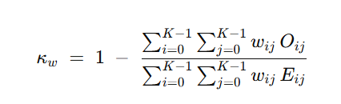
For quadratic weighting, the disagreement weights are typically defined as:
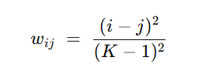
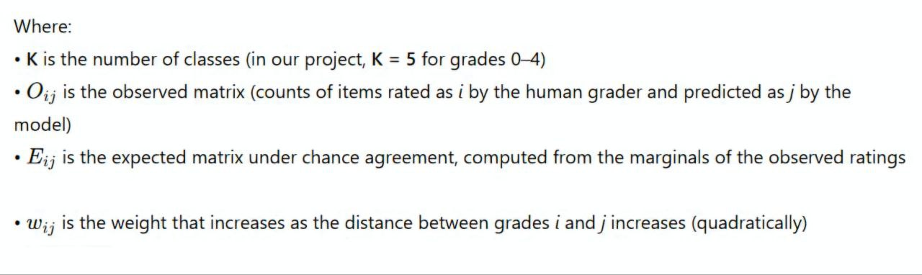

Chapter Literature Review

Introduction
In this chapter , we will review the literatures summary them and we will mention the gaps of each ones , additionally we will compare between them .

2.2.Used Tools
Parsifal is an open-source “web-based tool” designed to help researchers “conduct systematic literature reviews (SLRs)” in a structured,
collaborative, and efficient way. In our project, which focuses on "writer identification from Arabic handwriting using AI techniques”, we used Parsifal as a core platform to manage and analyze the existing body of research relevant to our topic.

2.2.1Apply of Parsifal in Our Project
We began by defining our research questions
Figure 1 .parsifal research question

Use advanced search with keywords like:
Figure 2. Parsifal Keyword used

Study Selection is a crucial step in conducting a Systematic Literature Review, this step follows your “review protocol”, especially the “inclusion and exclusion criteria” you defined earlier. Sush as :
Figure 3.Parsifal paper selection

2.3.Summary of the Accepted Papers:

2.2.1.An End-to-End deep learning system for writer identification in handwritten Arabic manuscripts
Michel Chammas, · Abdallah Makhoul· Jacques Demerjian· Elie Dannaoui
Published online: 6 December 2023

2.3.1.1.Paper summary:
Balamand Arabic historical dataset:
Arabic manuscripts date back to the seventh century, coexisting with printed books.
Manuscripts cover a wide geographic area and various topics.
Previous studies focused on individual manuscripts rather than quantitative analysis.
The dataset consists of 567 manuscripts digitized at the University of Balamand.
Size:
The dataset includes 11,610 digital photos from various manuscripts.
Most photos are in portrait format, with some combined into landscape photos.
Data:
Manuscript dates are often found in colophons, which are at risk of loss.
409 manuscripts have recognized dates, while 158 do not.
Copyists
The dataset identifies 256 copyists responsible for 329 manuscripts.

ICDAR 2019 Latin historical dataset
The dataset contains 3,600 documents from 720 writers for training.
It focuses on European Middle Ages writers, with many anonymous documents.
ICFHR 2020 Latin historical dataset

The dataset consists of 21,000 document images for 10,500 writers.
Originates from manuscripts written in the European Middle Ages.
KHATT Arabic non-historical dataset

The KHATT dataset includes 4,000 small paragraphs from 1,000 writers.
Data is divided into training, testing, and validation sets.

System description:
The initial system had three main functions: feature extraction, classification, and encoding.
The new end-to-end system uses an optimized DeepTen approach with a single pipeline.

Features extraction:
CNN is used for local feature extraction and image classification.
ResNet50 with Spatial Pyramid Pooling allows for variable input sizes.
The output is a D-Dimensional matrix of descriptors.
Encoding
Local feature vectors are passed to a NetVLAD network for global descriptor computation.
The network aggregates local features into a global descriptor vector.
Loss function:
The triplet loss function optimizes global descriptors for better recognition.
Hard-batch online triplet selection is used to improve convergence.

2.3.1.2.Contribution
Algorithm: The paper presents an end-to-end deep learning system based on the Deep-TEN approach, utilizing a customized ResNet-50 network for feature extraction and a NetVLAD layer for encoding global descriptors. .
Parameters:
- Loss Function: The system employs a triplet loss function .
- Batch Selection: A hard-batch online triplet selection method is used, where each minibatch contains P writers with K patches each. Specifically, the parameters are set as follows:
- P = 7 (number of writers)
- K = 3 (number of patches per writer)
- α = 0.1 (margin enforced between positive and negative pairs) .
- Optimizer: The Adam optimizer

Results Achieved
- The end-to-end system demonstrated impressive performance across various datasets. Specifically, it achieved:
- Mean Average Precision (mAP): 96.4%
- Accuracy: 99.2%

2.3.2.A deep learning based system for writer identification in handwritten Arabic historical manuscripts
Michel Chammas, · Abdallah Makhoul· Jacques Demerjian · Elie Dannaoui
Published online: 7 April 2022

2.3.2.1Paper summary:
Size
The corpus includes 567 manuscripts from Antiochian Orthodox collections in Lebanon and Syria.
Contains 11,610 digital photos, with varying formats for medium, large, and small manuscripts.

Date
Manuscript dates are often found in colophons, which are at risk of loss.
409 manuscripts have recognized dates, while 158 lack explicit dating information.

Copyists
Identified 256 copyists responsible for producing 329 manuscripts, with some manuscripts copied by the same hand.

System description
The writer identification system comprises feature extraction, classification, and encoding.
Normalization is applied to enhance recognition performance.

Features extraction
Image samples localized using SIFT for feature extraction, preserving sample properties.
PCA is applied to SIFT descriptors to improve performance and reduce dimensions.
Clustering
75 million descriptors were clustered into 5,000 groups using mini-batch k-means.
Extracted patches trained a deep CNN (ResNet20) for feature extraction.

CNN training
CNN mapped image patches to labels, using a deep residual network for descriptor extraction.
UBM model created from trained descriptors, clustered using k-means.

Encoding
A VLAD codebook was created for encoding documents, aggregating local descriptors into a global vector.
Multi-VLAD approach improved encoding performance, resulting in a reduced global descriptor.

2.3.2.2.Contribution:
Algorithms :Artificial Neural Networks (ANN) The paper discusses the use of various ANN algorithms for writer identification, including:
- Recurrent Neural Networks (RNN)
- Convolutional Neural Networks (CNN)
- Multilayer Perceptron (MLP)

- Feature Extraction and Classification: The system was built on three main functions:
- Feature Extraction This process involves identifying and extracting relevant features from the handwritten manuscripts.
- Classification: The extracted features are then classified to determine the writer's identity.
- Encoding: This step encodes the classified information for further processing .

- Results Achieved: The system demonstrated impressive performance metrics:
- mean Average Precision (mAP):95.2%
Accuracy:99.1%,

2.3.3.A model-based approach to offline text-independent Arabic writer identification and verification
Mohamed Nidhal Abdi, Maher Khemakhem
published on October 25, 2014

2.3.3.1.Summary
Proposed Approach
- Handwriting generation involves biophysical and psychological processes coordinated by the brain.
- The Beta-elliptic model is adapted for offline handwriting biometrics.
- The model quantifies handwriting shapes for writer identification and verification.
- Sections detail the model's assumptions, online and offline implementations, and codebook generation.

Beta-Elliptic Model
- The Beta-elliptic model is effective for online handwriting description and regeneration.
- It has not been previously used for writer identification.

Assumptions of the Model
- Assumption 1: Rapid handwriting movements result from neuromuscular synergy.
- Assumption 2: Velocity profiles can be decomposed into basic movement units.

Online Beta Model
- Handwriting is modeled as a velocity function over time.
- Stroke movements are represented as overlapping Beta functions.
- The online model needs adaptation for offline applications.

Offline Elliptic Model
- The Elliptic model represents handwriting ink trails for offline analysis.
- It computes parameters to describe strokes as elliptic segments.

Codebook Implementation of the Model
- Codebooks are used for handwriting biometrics, capturing invariant aspects of handwriting.
- The effectiveness of elliptic codebooks is demonstrated through experiments.

Codebook Generation
- The generation process includes feature generation and selection.
- An exhaustive number of elliptic graphemes is created for the raw codebook.

Feature Generation
- Graphemes are generated using elliptic parameters to form a raw codebook.
- The codebook is tested for writer-discriminatory potential.
Elliptic Template Library
- The library consists of binary templates representing one-pixel-width elliptic segments.
- Ellipses are generated at specific resolutions and angles.

Direction Sets
- Direction sets represent possible angles for grapheme generation.
- Five direction sets are constructed to capture various handwriting orientations.

Feature Selection
- Dimensionality reduction eliminates less informative graphemes from the raw codebook.
- Random subsampling outperforms training-based criteria in maintaining identification effectiveness.

Feature Extraction
- Feature vectors are computed by quantifying graphemes in handwriting samples.
- Template matching is applied across different application sets and resolutions.’

Application Sets
- The IFN/ENIT database is used for experiments, containing samples from 411 writers.
- Handwriting samples are pre-processed for feature extraction.

Resolution Sets
- Feature extraction is conducted at various resolutions to optimize identification.
- Resolution affects both texture dimensions and morphological characteristics of handwriting.

Template Matching Kernel
- Template matching quantifies elliptic grapheme codebooks in handwriting samples.
- A single morphological opening kernel is used for feature extraction.

Feature Vector Sets
- Feature vectors are derived from the grapheme codebook for analysis.
- The cardinality of the feature vector set is defined.

Experimental Results
- The approach is validated using the IFN/ENIT database for writer identification.
- Experiments assess the impact of Arabic morphology on identification rates.
Classification
- The χ² distance is used for ranking training samples in writer identification.
- Identification rates are presented as top-list measures for evaluation.

Writer Identification Raw Codebook Results
- The best identification rate of 90.02% was achieved at 300dpi resolution.
- Up sampling showed minimal impact on identification rates.

Feature Selection Results
- The full raw feature vector was retained for optimal identification performance.
- Random subsampling reduced execution time while maintaining effectiveness.
Writer Verification

- Confidence thresholds are computed for verifying writer identity.
- ROC curves and EER measures are used to present verification results.
Comparison with Literature

- The paper discusses the effectiveness of its approach compared to existing methods.
- Arguments are made regarding the advantages of the proposed method over others..

2.3.3.2.Contribution:
Algorithms Used
- The paper employs a grapheme-based approach for writer identification and verification, which synthesizes its own graphemes using the beta-elliptic model. This model allows for the generation of graphemes independent of any training process, enhancing the originality of the approach .
- For classification, various distance metrics are tested, including χ², weighted Euclidean distance (WED), and Manhattan distance, which are common in handwriting recognition tasks .

Feature Extraction
- The feature extraction process involves generating a full codebook and four partial raw codebooks based on the synthesized graphemes. .
- Features extracted include structural features such as directional/angular distributions and statistical features like texture measurements and grapheme distributions .
- A total of 60 feature vectors are extracted using template matching techniques, which are then evaluated against the dataset

Results
- The results indicate that the feature selection process, particularly using random subsampling, significantly reduces the codebook size while maintaining high identification rates. For instance, a raw codebook reduced from 48 × 48 to 14 × 14 still achieved a top-1 identification rate of 90.02%, with only a minor decrease in top-5 accuracy .

2.3.4.Arabic Writer Identification System Using the Histogram of Oriented Gradients (HOG) of Handwritten Fragments
Yaâcoub Hannad , Imran Siddiqi ,Youssef El Merabet, Mohamed El
Youssfi El Kettan

2.3.4.1.Summary
Proposed Methodology
- Methodology involves pre-processing, feature extraction, and classification.
- Key steps are illustrated in a referenced figure.
Pre-processing
- Images are converted o binary using Otsu thresholding.
- Connected components in the writing are extracted for further processing.

Feature Extraction
- Writing is divided into small fragments represented by vectors.
- Fragments are created from connected components using a fixed window size.
- Larger window size captures more handwritten text for meaningful feature computation.
- Each fragment is represented by HOG descriptors for effective writer identification.

Writer Identification (Classification)
- Query handwriting images are divided into fragments for HOG descriptor computation.
- Dissimilarity between query and reference samples is measured using Hamming distance.
Database
- The IFN/ENIT database contains 2,200 handwritten forms from 411 writers.
- It includes over 26,000 handwritten Tunisian town/village names in Arabic.

2.3.1.2.Contribution:
-Algorithm Used:
- The primary algorithm utilized in this study is based on the **Histogram of Oriented Gradients (HOG)** descriptor. This algorithm is designed to analyze small writing fragments to characterize the writer effectively .
Parameters:
- The system evaluates the performance of the HOG descriptor against other descriptors such as *Local Binary Patterns (LBP)*, *Local Ternary Patterns (LTP)*, and **Local Phase Quantization (LPQ)*.
The identification rates are compared to assess the effectiveness of HOG .
- The experiments were conducted using a database of *411 writers*from the IFN/ENIT database, where each writer's performance was evaluated based on a training set of *30 words * and a test set of *20 words*
RESULTS OF THE STUDY
-Identification Rate:
- The system achieved an impressive identification rate of **86.62%** when evaluated on the 411 writers. This rate indicates the effectiveness of the HOG descriptor in identifying writers based on their handwriting samples .
- Comparison with Other Descriptors:
- The identification rate obtained using the HOG descriptor outperformed that of the LBP descriptor and was very close to that of the LTP descriptor. However, the highest identification rate was realized by the LPQ descriptor
- Impact of Number of Writers:
- The study also noted a gradual decrease in identification rates as the number of writers increased, which is a natural occurrence in such identification systems. However, the identification rates remained relatively stable after reaching 200 writers, indicating that the HOG descriptor can effectively handle larger databases .

2.3.5.Intelligent Arabic Handwriting Recognition Using Different Standalone and Hybrid CNN Architectures

2.3.5.1.Summary
Parameters Used in the Study
- Model Architecture: The study utilized convolutional neural networks (CNNs) with various layers, including convolutional, pooling, and fully connected layers.
- Optimization Algorithms: Different optimization algorithms were employed, including RMSProp, Adagrad, stochastic gradient descent, and Adam Optimizer .

- Training Parameters
- Number of Epochs: 20
- Batch Size: 32
- Training Samples: 3600
- Validation Samples: 2400
- Total Parameters: 129,162 parameters were selected during model training, with 128,714 trainable parameters and 448 non-trainable parameters .

Results Achieved
- Accuracy Metric: The models demonstrated varying levels of accuracy when tested against the Arabic character dataset. The highest accuracy achieved was 0.65 for Logistic Regression and SVM (RBF kernel), while the lowest was 0.43 for SVM (linear kernel) .
- Performance of Models: Almost all models performed well, indicating effective fine-tuning to the dataset. However, the results for the Arabic character dataset were generally lower than those for the MNIST dataset, with hybrid models showing better performance than standalone models

Techniques and Innovations Used
- Transfer Learning: The study implemented transfer learning, which allowed the models to leverage pre-trained weights from other datasets, resulting in improved accuracy, particularly on the MNIST dataset where an accuracy of 0.9967 was achieved .
- Hybrid Models: The research focused on hybrid models that combined CNNs with machine learning algorithms, enhancing the overall performance of handwriting recognition systems .
- Pooling Techniques: Max pooling was used to reduce dimensionality and combat overfitting, which helped in adjusting the quality of parameters during training .

These parameters, results, and innovative techniques highlight the study's comprehensive approach to improving Arabic handwriting recognition through advanced machine learning and deep learning methodologies.

2.4.Comparation

Table 1.comparation
Paper Title | Dataset Used | Training Approach | AI Model | Feature Extraction | Evaluation & Result
An End-to-End Deep Learning System for Writer Identification in Handwritten Arabic Manuscripts(2023) | Balamand, KHATT, ICDAR 2019, ICFHR 2020 | End-to-End Deep Learning with Triplet Loss | ResNet-50 + NetVLAD | CNN + Spatial Pyramid Pooling | mAP: 96.4%, Acc: 99.2%
A Deep Learning Based System for Writer Identification in Handwritten Arabic Historical Manuscripts(2022) | Balamand Historical Dataset | Hybrid (SIFT + CNN + VLAD) | ResNet20, RNN, MLP | SIFT + PCA + CNN + Multi-VLAD | mAP: 95.2%, Acc: 99.1%
Hybrid Trainable System for Writer Identification of Arabic Handwriting(2021) | KHATT (4,000 samples, 1,000 writers) | Hybrid Deep + Feature Fusion with Augmentation | CNN + ResNet50 + ANN + SVM | HOG + CNN + Genetic Algorithm | Acc: 94.2% (paragraph), 83.2% (line), 78% (subword)
Intelligent Arabic Handwriting Recognition Using Different Standalone and Hybrid CNN Architectures(2022) | Custom Arabic character dataset (3,600 train, 2,400 val) + MNIST | CNNs + Hybrid CNN-ML with Transfer Learning | CNN variants, CNN+SVM | CNN layers + Transfer Learning | Acc: 0.65 (Arabic), 0.9967 (MNIST)
Arabic Writer Identification System Using the Histogram of Oriented Gradients (HOG)(2016) | IFN/ENIT (411 writers, 2,200 forms) | Classic ML with Fragment-Based Descriptors | HOG + Hamming Distance | HOG (fragment descriptors) | Acc: 86.62%
A Model-Based Approach to Offline Text-Independent Arabic Writer Identification and Verification(2015) | IFN/ENIT (411 writers) | Codebook-driven model, no ML | Beta-Elliptic Model + Template Matching | Grapheme-based (elliptic segments), direction sets | Acc: 90.02% (Top-1), optimized via resolution & codebook subsampling
5

2.5.Pros and Cons
Table 2pros &cons
Paper Title | Pros | Cons
An End-to-End Deep Learning System for Writer Identification in Handwritten Arabic Manuscripts (2023) | - State-of-the-art performance (mAP 96.4%, Acc 99.2%)- Fully automated end-to-end approach using Triplet Loss- Robust feature encoding via NetVLAD and Spatial Pyramid Pooling | - Computationally expensive to train and deploy- Requires large annotated datasets for Triplet Loss optimization
A Deep Learning Based System for Writer Identification in Handwritten Arabic Historical Manuscripts (2022) | - Hybrid method captures both handcrafted and learned features- High accuracy (Acc 99.1%) with Balamand Historical dataset- Uses RNNs for temporal analysis | - Complex pipeline (SIFT + PCA + CNN + Multi-VLAD)- Harder to generalize to modern handwriting due to historical dataset bias
Hybrid Trainable System for Writer Identification of Arabic Handwriting (2021) | - Combines deep learning and classic ML (CNN + SVM)- Uses feature selection via Genetic Algorithm- Works at multiple granularity levels (paragraph, line, subword) | - Lower accuracy at subword and line levels (78% - 83.2%)- Fusion architecture increases training complexity
Intelligent Arabic Handwriting Recognition Using Different Standalone and Hybrid CNN Architectures (2022) | - Good performance on MNIST (99.67%)- Uses transfer learning for boosting performance- Lightweight CNNs may offer fast inference | - Poor performance on Arabic dataset (Acc: 0.65)- Dataset size is small and lacks variability- Not focused on writer ID but on character recognition
Arabic Writer Identification System Using the Histogram of Oriented Gradients (HOG) (2016) | - Simple and efficient using classic ML- No need for large training data- Achieves decent performance (86.62%) | - Feature extraction is handcrafted (not learned)- Less scalable to large writer databases- Limited to visual structure, not style
A Model-Based Approach to Offline Text-Independent Arabic Writer Identification and Verification (2015) | - Fully model-based, avoids need for ML training- High accuracy (Top-1 Acc: 90.02%)- Effective for short fragments using grapheme direction | - Outdated compared to deep learning- Manual codebook creation and template tuning required- Performance depends on resolution and segmentation quality

2.6.Conclusion
The most effective approaches for Arabic writer identification are recent deep learning models, especially those using metric learning like Triplet Loss and ArcFace, which outperform hybrid and traditional methods in both accuracy and scalability. Classical models remain simpler but are less suitable for modern large-scale applications.

Chapter .3Project Management

3.1.Introduction :
In this chapter, we will introduce the proposed system for five-grade diabetic retinopathy (DR) classification (0–4) using the APTOS 2019 dataset. We will also present the project plan we followed, how we managed the work, and the completed requirements.

3.2.The objective of project management:
Apply knowledge, skills, tools, and techniques to project activities to meet project requirements, and organize resources so the project is delivered within the defined scope, quality, and time constraints.

3.3.Project charter:

Table 3Project charter
Project Title: Early Detection of Diabetic Retinopathy Using Deep Learning
Project start date:15\9\2025
Projected finish date :25\1\2026
Project manager: Dr. Nisreen Sulayman & Eng. Zeinab Baghdadi
Project objective: To build a high-accuracy deep learning model that grades diabetic retinopathy into five levels (0–4) on APTOS 2019, optimized using Quadratic Weighted Kappa (QWK).
Approach:
CNN (EfficientNetB3, transfer learning)
QWK-based five-grade DR grading (0–4) with optimized thresholding
Roles and responsibilities
Name | Role | Responsibilities
DR. Nisreen Sulayman |  | supervise
Zeinab Baghdadi |  | Supervisor
Mohammad Barazi | AI | Ai (training model )
Mohammad Khir Alhomsi | AI | Ai (training model )

Statement of Work (SOW)
Table 4Statement of Work (SOW)

Section | Description
Project Description | Development of a five-grade diabetic retinopathy (DR) severity grading system (0–4) from retinal fundus images using deep learning on the APTOS 2019 dataset. The approach leverages transfer learning with EfficientNetB3 and evaluates/optimizes performance using Quadratic Weighted Kappa (QWK), the standard metric in the APTOS 2019 setting, while applying imbalance-aware training to mitigate class imbalance.
Project Objectives | To achieve high-accuracy five-grade diabetic retinopathy (0–4) severity grading from retinal fundus images on APTOS 2019, apply preprocessing and imbalance-aware training to improve robustness, and evaluate the model under realistic validation conditions using Quadratic Weighted Kappa (QWK) as the primary metric.
Project Scope | The system is trained on the public APTOS 2019 retinal fundus dataset (3,662 labeled images) graded into five diabetic retinopathy severity levels (0–4), and is designed to operate effectively on fundus-image inputs under varying imaging conditions. The model is evaluated for robustness and grading agreement using Quadratic Weighted Kappa (QWK) (the APTOS 2019 scoring metric) under a validation protocol such as stratified cross-validation to account for the dataset’s class imbalance.
Project Deliverables | - A trained AI model for five-grade diabetic retinopathy (0–4) severity grading on the APTOS 2019 fundus dataset.  - A labeled and preprocessed retinal image dataset pipeline (cleaning, cropping/background removal, resizing, normalization) prepared for training and evaluation.  - Performance evaluation artifacts: Quadratic Weighted Kappa (QWK) scores (primary metric), confusion matrix, and supporting visualizations/plots.  - Complete technical documentation of the development process (dataset description, preprocessing steps, model architecture, training strategy, validation protocol, and final results).
Project Resources | Laptops/workstations with GPU support for training the DR grading model, and cloud-based compute environments (Kaggle) to accelerate deep learning experiments and model training on the APTOS 2019 retinal fundus dataset.
Project Constraints | • Limited labeled training data (APTOS 2019: 3,662 images) with a clear five-class imbalance (e.g., 1805/370/999/193/295), which can bias learning toward the majority grade.  • Restricted processing power and compute time for training/fine-tuning deep CNN models on high-resolution fundus images.  • Time limitations due to the academic calendar, constraining the number of experiments, hyperparameter searches, and repeated validations.
Project Technology and Tools | Python, TensorFlow, Keras, OpenCV, Jupyter Notebooks, Matplotlib, and Scikit-learn.
Acceptance Criteria | • Validation performance: Achieve a Quadratic Weighted Kappa (QWK) of 0.90 or higher on validation (primary metric for APTOS 2019), and report validation accuracy as a secondary metric.  • Functional AI model: A working model that reliably grades retinal fundus images into five diabetic retinopathy severity levels (0–4).  • Clean, organized dataset pipeline: A consistent and reproducible dataset setup with correct labels and standardized preprocessing (e.g., cropping/resize/normalization), suitable for training and evaluation.

4.5.Preliminary Scope Statement :
Table 5.Preliminary Scope Statement
Preliminary Scope Statement (4.5)
Section | Description
Project Objectives | Develop a scalable and accurate deep learning system for five-grade diabetic retinopathy (DR) severity grading (0–4) from retinal fundus images, with a focus on robustness, clinical relevance, and reliable evaluation within the APTOS 2019 setting
Project Boundaries | The system operates in an offline setting using static fundus images as input. It does not include real-time capture, medical device integration, or clinical deployment workflows. The scope is limited to DR grading on APTOS-style images and does not cover other eye diseases or multimodal patient data
Deliverables | - A fully trained and validated AI model for five-grade DR classification (0–4) on APTOS 2019.  - A curated and preprocessed dataset pipeline (e.g., cropping border artifacts, resizing, normalization).  - Visual performance outputs (training curves, confusion matrix, QWK/accuracy summaries).  - Technical documentation describing dataset, preprocessing, model architecture, training strategy, and evaluation.
Product Acceptance Criteria | - Validation accuracy of at least 90% (reported as a secondary metric).  - Primary evaluation reported using Quadratic Weighted Kappa (QWK), the official APTOS 2019 metric, with reliable performance across validation folds.  - Structured dataset pipeline with consistent labels (0–4) and standardized preprocessing.
Project Assumptions and Constraints | - Data is sourced from the public APTOS 2019 dataset (3,662 labeled images; grades 0–4).  - The dataset has class imbalance (e.g., 1805/370/999/193/295 for grades 0–4), requiring imbalance-aware training choices.  - Compute resources and time are limited, constraining extensive hyperparameter search and very large-scale experiments.
Organizational Structure | The project follows a flat academic structure with clearly defined roles among team members and direct faculty supervision for guidance, feedback, and milestone verification.
Initial List of Defined Risks | - Reduced performance on minority grades due to class imbalance.  - Variability in image quality (illumination, blur, artifacts) causing inconsistent predictions.  - Overfitting due to limited labeled data size and repeated experimentation.  - Metric mismatch if evaluation relies on accuracy instead of QWK for ordinal grading.
Summary of Schedule Milestones | - September: Dataset setup, exploratory analysis, preprocessing pipeline, and baseline model.  - November: Model training, cross-validation, tuning (imbalance handling, threshold optimization), and intermediate evaluation (QWK/accuracy).  - January: Final testing, results analysis (confusion matrix + QWK), and full documentation submission.

Risk Management :
Table 6.Risk Management

Risk | Date Raised | Frequency | Assigned To | State | Discipline | Impact / Probability | Mitigation Plan | Mitigation Responsibility | Proposed Response
Severe class imbalance across grades (0–4) leading to weak minority-grade performance | 15/10/2024 | Daily | AI Engineer | Open | Data (AI Dataset) | High | Use imbalance-aware training (sample/class weights), stratified validation, and monitor per-class errors | Data Analyst | Re-train with balanced weighting and validate with stratified K-Fold; report confusion matrix by grade
Image quality variability (illumination, artifacts, dark borders) reducing model robustness | 20/10/2025 | Weekly | AI Engineer | Open | Data (AI Preprocessing) | High | Standardize preprocessing (crop borders/background, resize, normalization) and use augmentation | Data Analyst | Strengthen preprocessing pipeline and augmentation; perform error analysis on failed cases
Overfitting due to limited labeled data size and repeated experimentation | 20/10/2024 | Weekly | AI Engineer | Open | Model (AI Algorithm) | Medium | Use regularization (dropout/early stopping), cross-validation, and checkpointing | AI Engineer | Apply early stopping + model checkpoints; compare folds to ensure stable generalization
Metric mismatch (high accuracy but low clinical agreement) if evaluation does not prioritize QWK | 25/10/2025 | Weekly | AI Engineer | Open | Evaluation (AI Metrics) | High | Use QWK as the primary metric; calibrate predictions (e.g., threshold optimization for ordinal grades) | AI Engineer | Optimize mapping to discrete grades to maximize QWK and report both QWK + accuracy

Chapter 4.Dataset collection

4.1.Introduction
In this chapter, we will discuss the dataset used in our project. Datasets play a crucial role in the success of any trained model, because they provide the information that the model learns from and uses to make predictions.

4.2.APTOS 2019 Dataset
The APTOS 2019 Blindness Detection dataset is designed to support research on automated diabetic retinopathy (DR) grading from retinal fundus images. Each image is labeled by a clinician with a severity grade on a five-level scale (0–4), where 0 indicates No DR and 4 indicates Proliferative DR.
The dataset provides 3,662 labeled training images, and a separate test set of 1,928 images (without public labels in the original competition setting).

4.2.1.Structure of the APTOS 2019 Dataset :
The dataset is typically organized as follows:
- Fundus Images: Each sample is a retinal fundus photograph stored as an image file. Image quality varies due to different acquisition conditions (illumination, focus, borders, and background).
- Labels (Diagnosis): Each training image has a ground-truth label representing DR severity from 0 to 4.
- Metadata File: A CSV file (commonly train.csv) links each image id to its diagnosis label (0–4).

4.2.2.Availability

The APTOS 2019 dataset is publicly available through Kaggle as part of the APTOS 2019 Blindness Detection competition resources and is widely used for research and benchmarking in DR severity classification.
A key characteristic of this dataset is the class imbalance across the five grades. A commonly reported distribution for the training set is:
- Grade 0: 1805
- Grade 1: 370
- Grade 2: 999
- Grade 3: 193
- Grade 4: 295
Figure 4.Sample of Dataset KATT

4.2.3Data preprocessing
To improve training stability and reduce noise caused by real-world acquisition variability, we applied preprocessing steps tailored for fundus images:
- Border/Background Removal (Cropping): Many fundus images include dark borders or non-informative background regions. Removing these regions helps the model focus on the retinal area. This is a common preprocessing step in APTOS-based pipelines.
- Resizing and Standardization: All images were resized to a fixed input size required by the model to ensure consistent tensor shapes during training.
- Data Augmentation: We used augmentation (e.g., flips/rotations/zoom/contrast) to increase variability and reduce overfitting, which is especially helpful when some grades have fewer samples.

4.3.Dataset Splitting for Training and Validation
Because the dataset is imbalanced, we used a validation strategy that preserves grade distribution across splits to produce more reliable evaluation results. This helps ensure that minority grades appear in both training and validation subsets and reduces evaluation bias caused by random splitting.
If you want, paste your exact subsection titles under Chapter 4 (as they appear in your report template), and I will align the numbering and headings to match your document precisely (while keeping the same writing style).

Figure 5.Sample of our Dataset

Chapter 5. Implementation

5.1.Introduction
In this chapter, we will present the implementation details of our diabetic retinopathy (DR) grading system, including the model design, the training and fine-tuning procedure, and the evaluation metrics used to assess performance. Since APTOS 2019 uses Quadratic Weighted Kappa (QWK) as the primary scoring metric, our implementation and reporting are aligned with QWK-based evaluation.

5.2Objective of the Project
The goal of this project is to build an artificial intelligence system capable of classifying retinal fundus images into five diabetic retinopathy severity grades (0–4) using the APTOS 2019 dataset. The system learns discriminative visual patterns from the retinal images and produces predictions that reflect the ordinal nature of DR severity, while being evaluated using QWK as in the APTOS 2019 setting.

5.3Dataset Overview
• Dataset Name: APTOS 2019 Blindness Detection
• Task: Five-grade DR severity classification (0–4)
• Training Set: 3,662 labeled images
• Test Set: 1,928 images (labels not provided in the original competition setting)
• Challenge: Class imbalance across the five grades (common issue in APTOS 2019)
• Preprocessing (Implemented):
• Cropping to remove dark background/borders (focus on the retinal region)
• Resizing images to a fixed input size (300×300)
• Data augmentation during training (RandomFlip / RandomRotation / RandomZoom/Contrast)

5.4Model Architecture
• Backbone Model: EfficientNetB3 (transfer learning)
• Input: Preprocessed RGB fundus images (300×300)
• Output: A single continuous value (regression-style output), later mapped to discrete grades (0–4)
• Why EfficientNet: EfficientNet introduces compound scaling (depth/width/resolution) to improve accuracy–efficiency trade-offs and is widely used as a strong pretrained feature extractor.

5.5 Training Details
• Cross-Validation: Stratified 5-Fold (to preserve class distribution per fold)
• Batch Size: 8
• Optimizer: Adam
• Training Strategy: Two-stage transfer learning
- Warm-up (Feature Extraction):
  - Base model frozen
  - Epochs: 2
  - Adam learning rate: 1e-3
- Fine-Tuning:
  - Base model unfrozen (partial fine-tuning)
  - Epochs: 5
  - Adam learning rate: 5e-5
• Callbacks (Used): ModelCheckpoint, EarlyStopping, ReduceLROnPlateau
• Imbalance Handling (Used): Sample weights computed using inverse frequency weighting and passed through the training dataset (imbalance-aware training).

5.6Results

5.6.1 QWK Over Epochs (Validation Performance)
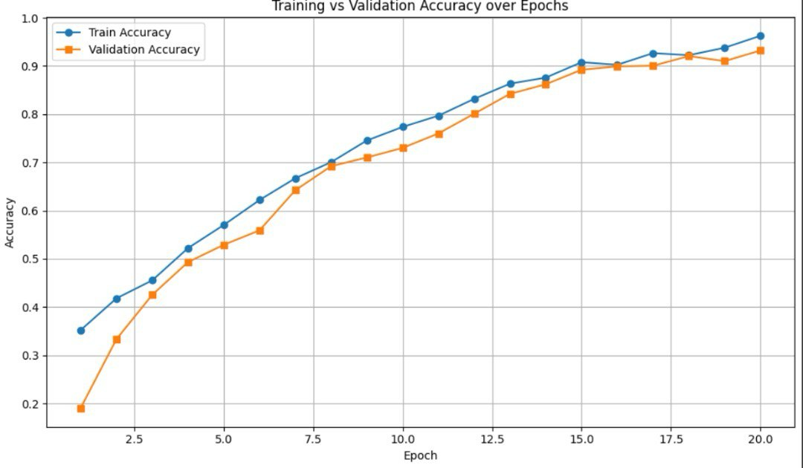
Figure 13.Traning and Validation Accuracy

Since APTOS 2019 uses Quadratic Weighted Kappa (QWK) as the official metric, we tracked QWK per epoch using cohen_kappa_score(..., weights="quadratic").
From the training logs in our notebook (5-fold CV), the best validation QWK per fold was:
- Fold 1: 0.88669
- Fold 2: 0.85499
- Fold 3: 0.86312
- Fold 4: 0.84679
- Fold 5: 0.84940
Cross-validation summary:
- Mean best-fold QWK: 0.86020
- Std (fold-to-fold): 0.01438
- Best fold QWK: 0.88669
Interpretation: QWK improved early in training and remained stable across folds, indicating consistent performance despite class imbalance and acquisition variability.

5.6.2 Threshold Optimization (Score-to-Grade Mapping)

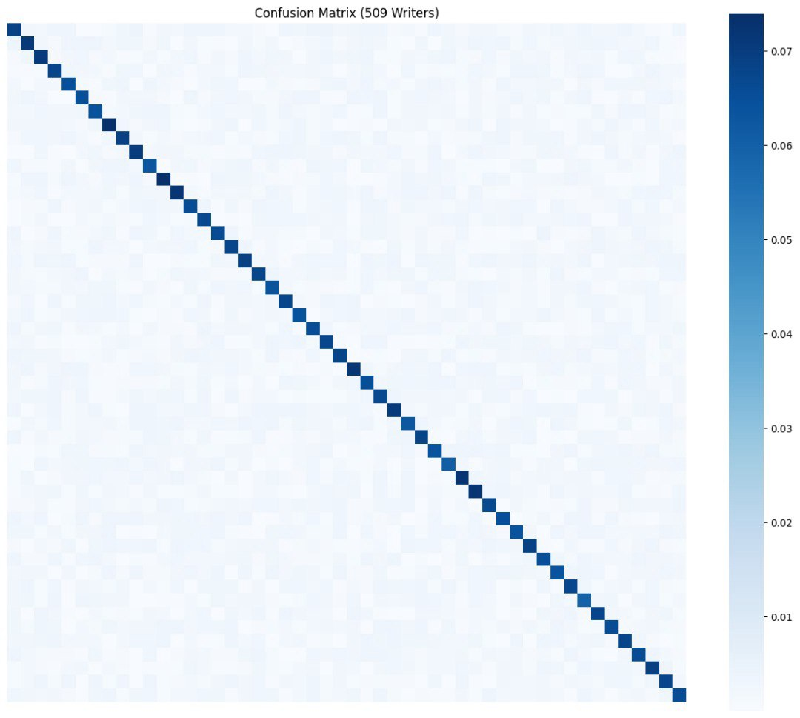
Figure 14.Confusion Matrix

Because DR grading is an ordinal problem and the model outputs a continuous score, we applied optimized thresholding to map predictions to the discrete grades (0–4). This approach is commonly used to better align predictions with QWK-based evaluation (compared to naive rounding).
In the code, we compute:
- OOF QWK (naive rounding): printed as OOF QWK (naive rounding): ...
- Optimized thresholds: printed as Optimized thresholds: ...
- OOF QWK (optimized thresholds): printed as OOF QWK (optimized thresholds): ...

Chapter 6.Research Gaps and Future Direction

6.1Introduction
This chapter outlines the key research gaps identified throughout the development of our five-grade diabetic retinopathy (DR) grading system using the APTOS 2019 fundus dataset. These gaps range from dataset limitations and class imbalance to model design choices, generalization under domain shift, and clinical interpretability. Addressing these gaps can improve both performance and real-world reliability, and it also opens clear future research directions for DR screening and severity grading systems.

6.2Feature Representation Limited to Static Global Patterns
Gap
Although CNN backbones such as EfficientNet provide strong global feature extraction, fundus-based DR grading often depends on fine-grained local lesions (e.g., microaneurysms and small hemorrhages). A global-only representation can miss subtle local cues, especially in early grades (mild/moderate), where discriminative signs may be small or sparsely distributed.
Reason Not Addressed Now
Incorporating multi-scale lesion-aware designs (e.g., attention modules or specialized lesion branches) typically requires deeper architectural changes, higher-resolution training, and longer experimentation cycles, which were beyond the scope of the current implementation phase.
Future Direction
Explore attention-based and multi-scale feature extraction (e.g., spatial/channel attention, transformer-inspired blocks, or feature pyramids) to improve sensitivity to small lesion patterns while maintaining stable performance across all five grades.

6.3 Class Imbalance Handling Without Broader Comparison

Gap
APTOS 2019 is clearly imbalanced across the five grades (commonly reported as 1805/370/999/193/295 for grades 0–4). While using class/sample weights helps, it does not fully solve minority-grade underperformance, and it was not compared against other imbalance strategies (e.g., focal loss, balanced sampling, synthetic augmentation methods, or hybrid resampling).
Reason-Not-Add-ressed-Now
A systematic comparison of imbalance-handling methods requires controlled experiments, consistent validation protocols, and careful tuning, particularly because different strategies can improve minority recall while harming calibration or increasing false positives.
Future-Direction
Conduct an ablation study comparing class/sample weighting against alternative approaches (e.g., focal-style objectives, balanced batch sampling, or targeted augmentation). The goal is to improve performance on severe/proliferative grades without degrading overall QWK.

6.4Metric Alignment and Ordinal Modeling Limitations
Gap
APTOS 2019 evaluation is based on Quadratic Weighted Kappa (QWK), which reflects ordinal distance between grades. Even when QWK is used for evaluation, training objectives often remain generic (e.g., cross-entropy or standard regression losses), which may not fully align optimization with ordinal agreement.
Reason Not Addressed Now
Directly optimizing ordinal-aware objectives or differentiable kappa-style losses can introduce training instability and requires careful validation to ensure improvements generalize beyond the validation folds.
Future Direction
Evaluate ordinal-specific learning formulations (e.g., ordinal regression objectives, cumulative link models, or differentiable approximations that better correlate with QWK), and compare them to regression + threshold optimization in a controlled setting.

6.5Generalization Under Domain Shift and Image Quality Variability
Gap
APTOS 2019 fundus images are captured under varying acquisition conditions (illumination, contrast, and artifacts). This variability can cause domain shift, where a model performs well on the benchmark but degrades when applied to images from different devices, clinics, or populations.
Reason Not Addressed Now
Robust generalization typically requires multi-dataset training, external validation (e.g., on Messidor/EyePACS), or explicit domain adaptation—none of which were included in the current phase focused on APTOS-only implementation.
Future Direction
Perform external validation on additional DR datasets and investigate domain-robust techniques (e.g., stain/illumination normalization, domain adaptation, test-time augmentation, or federated training where appropriate).

Chapter 7.Conclusion

Conclusion
The study confirms that deep learning models, particularly those enhanced by metric learning like ArcFace, offer superior performance in Arabic writer identification tasks compared to traditional methods. The custom-built dataset and systematic evaluation process helped validate the effectiveness of the ResNet-50 + ArcFace pipeline. The system demonstrated high accuracy in recognizing handwriting across hundreds of writers, reinforcing the potential of AI in biometric handwriting analysis. However, limitations such as reliance on static image features, lack of comparison with alternative losses, and exclusion of sequential stroke dynamics remain. Future work will aim to incorporate attention mechanisms, evaluate alternative metric loss functions, and explore sequence-aware architectures using digital handwriting inputs to further improve precision and adaptability

Chapter 8. References

[1]. Saleem Ibraheem Saleem and Adnan Mohsin Abdulazeez (2020), Hybrid Trainable System for Writer Identifications of Arabic Handwriting.
[2]. SA Mohammad (2014), KHATT
[3]. https://www.w3schools.com/django/index.php
[4].Russell, S., & Norvig, P. (2016). Artificial Intelligence: A Modern Approach. Pearson.
[5]. Murphy, K. P. (2012). Machine Learning: A Probabilistic Perspective. MIT Press.
[6]. Guo, P., & Yu, M., & Shen, L., & Lin, Z., & An, K., & Wang,J. (2024). Single-Channel Blind Source Separation in Wireless Communications: A Complex-Domain Deep Learning Approach. IEEE WIRELESS COMMUNICATIONS LETTERS, VOL(13), 6(s).
[7]. Ansari, S., & Saad Alatrany, A., & A. Alnajjar, K., & Khater, T., & Mahmoud,S., & Al-Jumeily, D., & Jaafar Hussain, A. (2023). A survey of artificial intelligence
[8]. Proakis, J. G., & Manolakis, D. G. (2007). Digital Signal Processing: Principles, Algorithms, and Applications. Pearson.

